Welcome to the first VRPA Virtual Conference!

This is a quick tips sheet for using Zoom!
If you have more questions than this sheet can answer head over to the Zoom Help Center!

How do I make someone else the host of a meeting?
- Start meeting as the host
- In the host controls, click “End”
- Click “Leave Meeting”
- Assign someone (The Moderator) to be the new host, then click “Assign and Leave”

How do I set a background image?
- Click on the arrow or carrot just to the right of the “Stop Video” Icon
- Select “Video Settings”
- Then select “Virtual Background” from the list on the left
- Select the background that you’d like to use
Video: Virtual Backgrounds

How do I add a “Virtual Background” image from my computer?
- Click on the arrow or carrot just to the right of the “Stop Video” Icon
- Select “Video Settings”
- Then select “Virtual Background” from the list on the left
- You will see default virtual backgrounds
- To the right of these is a “Plus” icon
- Click the “Plus” icon
- Select “Add Image” from the dropdown menu
- Select image from computer & click “Open”

What makes a background image work well?
- Use bright even lighting
- Use a solid color backdrop (this refers to what is behind you in your home), preferably green
- Do not wear clothing that is the same color as your backdrop
- Use Zoom resolution guides for images/videos for best results

How do I “Spotlight” the presenter?
- Hover over the video of the participant that you want to spotlight and click the ellipsis (...)
- A dropdown box will appear
- Select “Spotlight Video”

How do I cancel “Spotlight”?
Click “Cancel Spotlight Video” in the upper-left corner

How do I RECORD?
- Click on the “Record” icon at the bottom of your screen
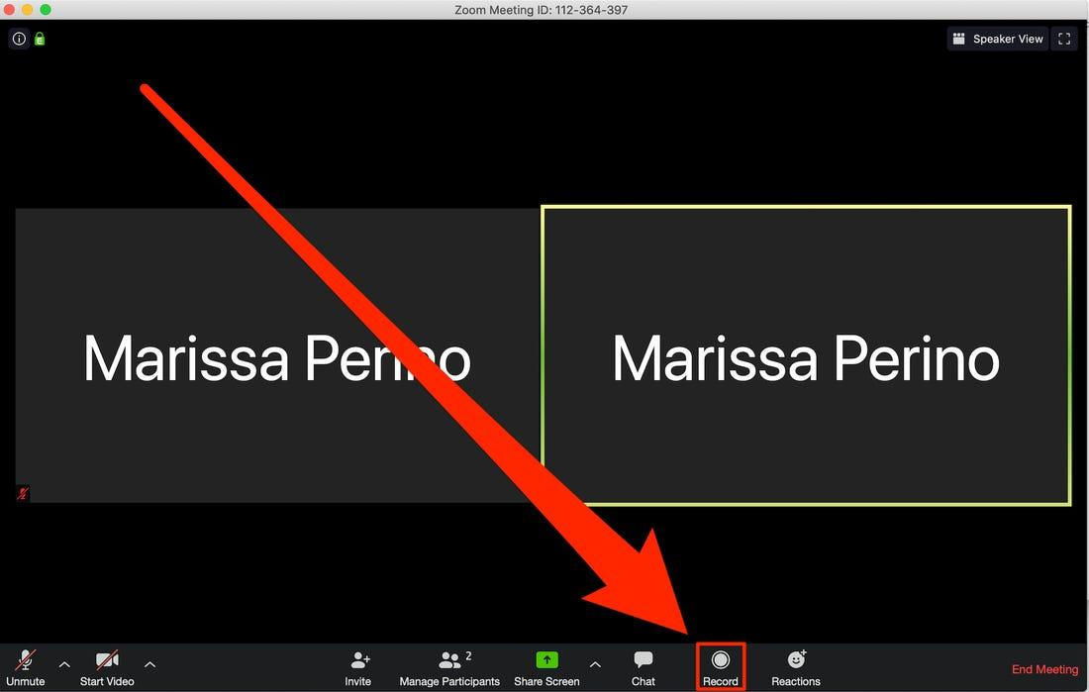
- A menu will appear
- Select “Record to the Cloud”
- You should be recording now
- Look in the upper left hand corner of your screen to ensure you see the Recording icon in red.
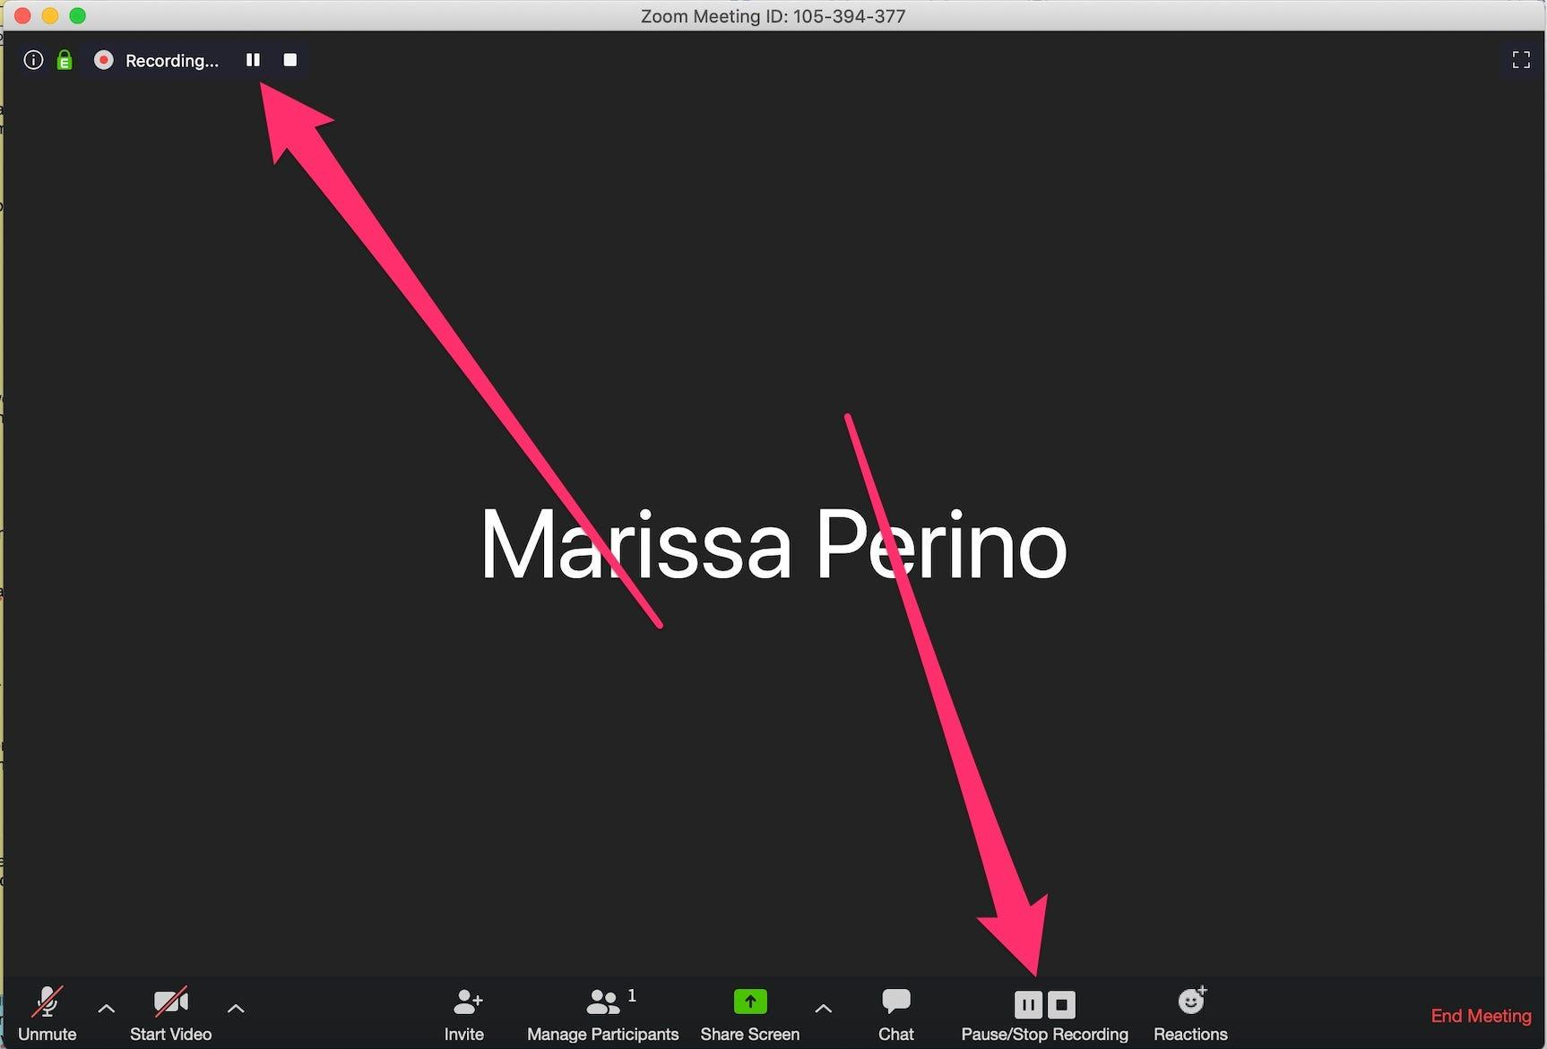

How do I stop recording?
- When you are recording “Pause/Stop” icons appear at the bottom of your screen
- Click on the “Stop” icon (black square) to end the recording (see above image)

I’m playing a video. How do I share the video with sound?
- Click the “Share Screen” icon located in your meeting controls at the bottom of your screen
- Select a screen share option
  - Share your entire desktop, a specific application window, whiteboard, or iPhone/iPad screen
- In the bottom left hand corner of the share menu there is a “Share Computer Sound” checkbox
- Check this option to allow video sound to play
- Click “Share Screen”

*Remember that if you choose to “Share Computer Sound” it will play ALL of your computer’s sounds during the presentation, so make sure to have your emails & other notifications turned off.*

How do I know people want to be let into the Zoom Session & how do I let them in?
- There will be a note that flashes at the bottom of your screen when a person is in the ‘waiting room’.
- Click on the “Participants” icon at the bottom of your screen. This will open a window that lists people in the ‘waiting room’.
- Click on “Admit” to give someone access to the session

How do I remove a participant from a meeting?
- Click on the “Participants” icon or Manage Participants
- A list of the participants will open
- Click on the participant’s name and a menu of options will appear
- Choose “remove”

How do I mute everyone in the meeting (this will mute the presenters as well)?
- Click “Participants”
- Click “Mute All”

How do I access the chat?
- At the bottom of your screen are meeting controls, represented by a series of icons.
- Click on the ‘chat’ icon in the meeting controls. This will open a chat box. It will appear on the side of the video chat portion.
- You can both enter comments and read what others have written.

