Worksheet for Preventing and Addressing Substance Misuse:
What Parks and Recreation Departments Can Do

Scenario: An 11-year-old boy in your summer camp has been having bad behavior all day. While playing a sporting activity he hit another young person with a ball hard enough that they started crying. During lunch he threw some food at a different young person and when confronted by staff, he yelled and swore at them.
- What actions would staff in your P&R Dept most commonly take to address this behavior?

- What happens most commonly when a child demonstrates this kind of behavior regularly?

Brain Development and ACEs:
In what ways is the science of brain development and childhood trauma toxic stress already a part of youth programming at your P&R Dept?

What elements of brain development and toxic stress are new to you?

Is there anything you might want to change about your programming based on any new information?

Strategies for Prevention:
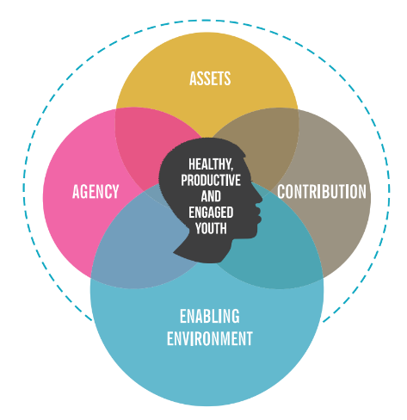
Program Improvements: Positive Youth Development Framework

Assets and Agency:
- Skill building and SEL
- Restorative practices for resolving conflict
- Developmental relationships
Contribution:
- Community service
- Leadership development
- Youth input for programming

Enabling Environment:
- Coaches and staff are positive role models
- Trauma-responsive approach
- Inclusive of all kinds of young people
- Clear and consistent norms and expectations about health, relationships and forms of engagement
- Connections to local behavioral health providers for support

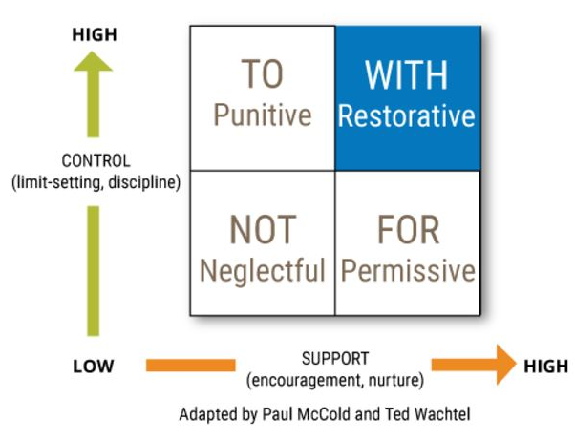
Scenario Review:
- Using a trauma-responsive, restorative approach, how might staff handle this situation?

- What programming or practice changes could staff make to prevent this kind of behavior in the future?

- What additional training might staff need to use this approach?

- What policy changes might need to be made in order to have the approach become common practice?

Strategies for Addressing Substance Misuse:
Creating safe public spaces
Creating a Recovery Ready Community
- Reduce stigma by using destigmatizing language
- Recruit and hire people in recovery
- Market services to people in recovery
- Provide substance free community building events
- Signs to limit public substance use
- Community Sharps Program

Harm Reduction strategies
- Narcan availability in Rec Centers and Public Buildings
- Training public facing staff in Narcan administration

Toolkit: https://pttcnetwork.org/centers/new-england-pttc/product/new-england-pttc-launches-new-parks-recreation-department-toolkit

