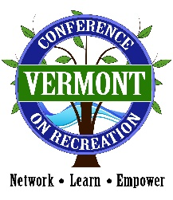
Vermont’s Finest Silent Auction
77th Vermont Conference on Recreation

Start: September 22, 2020 @ 4:30 AM
End: September 24, 2020 @ 4:15 PM
https://www.32auctions.com/VRPAannualconference2020

The silent auction has been a highlight of our annual conference for many years. We have decided to keep our tradition going with a Virtual Auction! This auction showcases premiere Vermont products, retailers, attractions, lodging, restaurants, adventures, skiing, golf, publications, and more.

Please visit the link above to View All Items that are listed in our auction. All Silent Auction Items will be posted to the website with a picture of the item, value, and the bidding increments. Items will be mailed or arrangements for pick up can be made after the conference by emailing Joanne Putzier at jputzier@burlingtonvt.gov.

All proceeds of the silent auction help provide conference scholarships for students and educational opportunities for members of the Vermont Recreation and Parks Association. Join us in bidding on a variety of fun, exciting and rewarding gifts and opportunities!

As the great Todd Goodwin would say “Bid High and Bid Often- There are No Friends in Silent Auctions”

We look forward to your contribution to our auction!

