Round Robin Tournament
Explanation:
A round robin is a competition in which each team meets all other teams in the pool. A round robin is different than an elimination tournament, as no player or team is eliminated after a certain number of losses. Rather, each player/team plays the same number of matches. The winner is determined by either who won the most matches or who accumulated the most total points.

As an example, in our state tournament if there are 7 teams entered in the over 70 Men’s Advanced Skill Level North Qualifier on three courts, it would look like this:

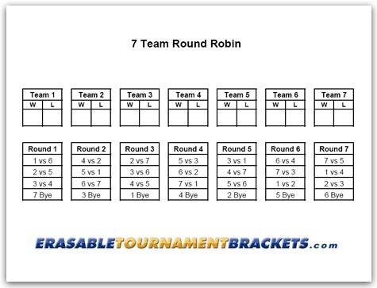

This is just an example as in our tournament we would add the points together that each team accumulated to determine the winner rather than wins and losses. As an example of our format, if Team 7 won each of their 6 games (remembering that we are going with first team to 11 and not “win by two point if both teams are tied at 10), their point total would be 66. If Team 2 won 3 games and lost 3 games (5-11, 6-11 and 7-11), their point total would be 33 points (from their wins) plus 18 points (from their losses) for a total of 51.

The are several things about round robins that make them the most attractive option.
- Teams are guaranteed multiple games rather than in a double or single elimination where teams have no certainty that they could play more than one or two. The round robin format has been proven to generate the highest level of interest from tournament players.
- The round robin format is highly flexible and can be adapted to any number of teams - large or small. It is a concept as you can run the round robin format across multiple divisions/brackets (regardless of the size of each division/bracket) so that the result will be the result of multiple games for each team across common opponents leading to the fairest result. It is almost certain that each skill/age/gender Qualifier bracket of our tournament will look different as it will be totally dependent upon the number of teams entered. Our Championship on the other hand, if 2 teams advance in each category from the Qualifier, the round robins will be identical.
- It is easy to administrate as we will provide each venue with the necessary round robin format dependent upon the number of teams participating. The actual scoring and winner determination is intuitive and provides the fairest result as noted above.

