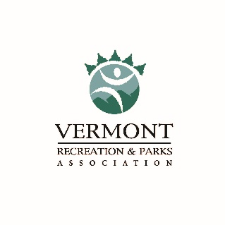
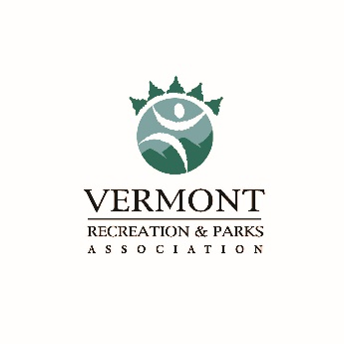
Vermont Recreation and Parks Association
December Quarterly Meeting
Thursday, December 5, 2019

“Outdoor Hub” in Randolph, VT
16 Pleasant Street, Randolph, VT 05060

VT “Alphabet Soup”
What RASTA, SCORP, VOREC, & VOBA mean to all of us and why they are important (0.1 CEU)

Maybe you’ve heard some of these acronyms before but were not sure what they mean? Come join us for a fantastic panel discussion where we will learn more about each of these groups & initiatives, and why they are important to us.

- Hear from Zac Freeman with the Rochester/Randolph Area Sport Trails Alliance (RASTA) about the recent grants they received, the new High School Cycling Team, and all the other great things going on in Randolph!
- Learn from Amy Kelsey & Kelly Hamson, UVM Research Specialists as they explain the goals and objectives of the Statewide Comprehensive Outdoor Recreation Plan (SCORP) and how you can help, & why this is important!
- Hear from representatives from the Vermont Outdoor Recreation Economic Collaborative (VOREC) to better understand how municipal Parks & Recreation professionals can help with these efforts!
- Hear from Kelly Ault, Executive Director of the Vermont Outdoor Business Alliance (VOBA) about their 1st Annual Summit and connected relationships & goals we all may have and how you can help!
- Meet with Megan Bullard & Amy Sear from the VT Chamber of Commerce to learn things they are doing to support outdoor Recreation in the state!

Building relationships with other Associations in the state is important, and we are excited to have this great group of professionals joining us together! In this educational session, you will learn about each group, their mission/goals/objectives, and why and how we should all be involved with them. There will be plenty of time for questions & answers so please bring your questions.

Panelists:
Zac Freeman & Angus McCusker, RASTA Amy Kelsey & Kelly Hamson, UVM - SCORP
Josh Hanford, VT State Parks - VOREC Kelly Ault, Executive Director – VOBA
Megan Bullard & Amy Spear, VT Chamber of Commerce Haidi Arias – Recreation Director, Town of Randolph

MEETING AGENDA

8:30 – 9:00 am Refreshments and Networking
9:00 – 9:15 am Welcome & Introductions
9:15 – 10:45 am Education Program (0.1 CEU)
Panel Discussion about RASTA, SCORP, VOREC, VOBA, & the VT Chamber of
Commerce
10:45 – 11:00 am BREAK
11:00 – 12:00 pm VRPA Business Meeting
12:00 – 12:30 pm Roundtable Discussions (Choose One) – Topics: Special Events, Summer
Programs, Capital Project Planning & Management, Finances & Budgets
12:30 – 1:30 pm LUNCH and Yankee Swap (bring a $5 gift if you want to play)
1:30 – 3:00 pm Committee Meetings – 2020 Summerama and 2020 State Track Meet

MEETING REGISTRATION - CLICK HERE to REGISTER ONLINE

Meeting Registration Fees: $25.00 (includes morning snack & lunch)
$10.00 (no lunch)

Please register by Friday, November 29th. Thank you!
Questions or Registration Problems? Contact Jessica Brodie at Jessica@vrpa.org or 774-254-0071.
Directions: From the north or south via I-89, take Exit 4, the Randolph exit. At the end of the exit ramp, turn onto Route 66 heading west, down the hill into town. Stay on this road for approximately 3 miles. At the four-way stop, head straight on Route 12. Bear to the left at Cumberland Farms then go past the Chandler Music Hall, and take your next left onto Pleasant Street. You will then see the Outdoor Hub on your left just before Prince Street. There is plenty of free parking within easy walking distance. If you are using GPS, enter the address as 16 Pleasant Street, Randolph VT.

