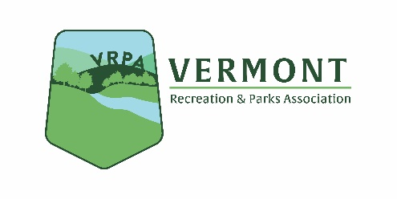
VRPA Discount Ticket Sales Program
2021 Pricing Information & Codes

Six Flags New England
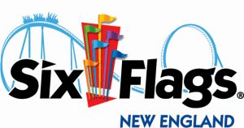
2021 Discount Prices:
$33.99 per person
Children under 2 are FREE

Code: VTREC2021
Website address: https://www.sixflags.com/newengland

Prices may fluctuate throughout the year depending on the dates and days of the week.
Passcodes & ticket prices are subject to change

Other details for departments:
Please advise employees and members to visit the Six Flags New England home page at https://www.sixflags.com/newengland and click the ENTER PROMO link in the top red banner on the right. This will pull up a box to enter in VTREC2021 (not cap sensitive), then click GO. This opens the web store with your $37 ticket and discount parking available. At checkout there will be a single $8.99 service fee, for one ticket up to 99, so encourage members to make one transaction to not pay additional fees.

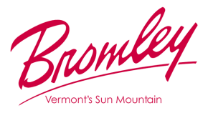
Bromley Adventure Parks

2021 Discount Prices:
$39 per person

Code: VTREC2021
Website: https://www.bromley.com/the-mountain/attractions/mountain-adventure-park/

*See Attached 1-page summary with more details
Passcodes & ticket prices are subject to change
Two other small reminders: this code will only be good for MAP tickets (as the tickets were) so if guests try to use it on a Double or Triple Play, or Aerial Adventure Park pass it will not work.
There are no upgrade discounts, since our combo passes are already discounted, we do not combine discounts. If they wish to upgrade, they will pay the difference ($30 for our Double Play, $40 for our Triple).

Below is a link to download high res photos of the Mountain Adventure Park attractions.
https://drive.google.com/drive/folders/1wvG-jDjZSPtailXB8ND1okiHKfUGZOlh?usp=sharing

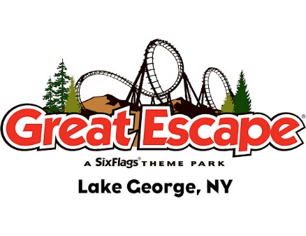
Six Flags Great Escape

2021 Discount Prices:
$25 per person Good Any Day Ticket
$15 - Parking Pass
+ discounted pre-purchased Mega Meal Deals with promo code (details available in coming weeks)

Code: VRPA21
Website: https://www.sixflags.com/greatescape

Prices may fluctuate throughout the year depending on the dates and days of the week.
Passcodes & ticket prices are subject to change.

Other Details for Departments:
Please advise employees and members to visit the Great Escape home page at https://www.sixflags.com/greatescape and click the Promo Code link in the top red banner on the right. This will pull up a box to enter in VRPA21 (not cap sensitive), then click GO. This opens the web store with your $30 ticket and discount parking available. Customers will then be required to enter contact information for each ticket as required by NYS COVID guidelines. At checkout there will be a single $8.99 service fee, for one ticket up to 99, so encourage members to make one transaction to not pay additional fees. If members complain or ask about the fee, please remind them that in 2019 VT Park & Rec tickets were $41, so even purchasing a single ticket with the service fee is less than in 2019.
After tickets are purchased, guests must make a reservation before visiting the park at https://www.sixflags.com/greatescape/reserve
Currently we still operating under reduced capacity from NYS guidelines. Guests will pick a day and timeslot in increments of 15min, and once confirmed will receive a digital confirmation to present when arriving at the park. Great Escape is conducting temperature screening at park entrance, but no proof of vaccination or negative COVID test is required. Effective May 22, fully vaccinated (10 days past vaccination) guests will no longer be required to wear face masks in our park or our lodge on an honor system. We will continue to recommend masks for unvaccinated individuals. Great Escape is only accepting card & mobile payments. They can convert cash to a prepaid debit card for no upfront fee immediately inside the park entrance or at any of the other Cash to Card kiosks within the park.
Mega Meal Deals include a meal, snack, and drink bottle with unlimited fountain beverages for redemption anywhere in park. Promo code will work on these in the coming weeks.

