Vermont Recreation & Parks Association
2020-21 ANNUAL REPORT
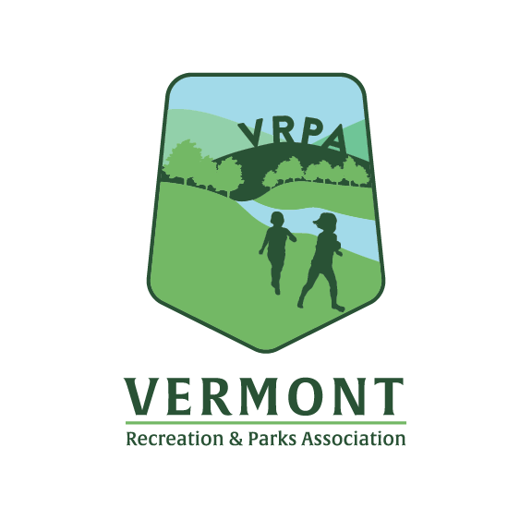

INTRODUCTION

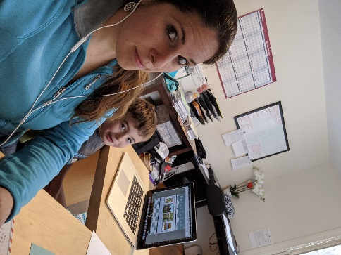
With change, comes new opportunities. This past year has been one the most difficult and challenging years that we have all experienced. Through cancelled programs, closed facilities, cut budgets, furloughs, and uncertainty we all still pressed forward to serve our communities in new ways. The programs and parks that you all managed this year gave residents places to go and ways to connect when we couldn’t. We have all learned to “Zoom”, share screens and Google drives, along with countless other new technology skills. The pandemic may have kept us all apart the past year physically, but it brought us all together in many other ways as well.

This past year we all faced similar and unique challenges and came together through a variety of new meetings. We started holding monthly Director’s meetings, along with a variety of sector specific meetings that we plan to carry on in the future. So much has changed this past year and that is not always a bad thing. Here at the VRPA we are excited to keep serving the amazing parks & recreation professionals in Vermont to help build community through people, parks, and programs.

WORKSHOPS & TRAININGS

The VRPA offers a variety of workshops and training programs through the year. Some of our larger events are highlighted below, but we also provide necessary training opportunities for a variety of certification programs. In 2020, we had to get creative, and virtual, to host our tradition workshops. After changing some dates around in the Spring of 2020, and coming up with new ways to offer courses, we were able to host a Certified Pool Operator (CPO) Training Course virtually. We had 17 participants for the course, which is lead by Nationwide Aquatics Consulting. This course is planned to be an annual offering in future years.

We also offered a virtual CPSI (Certified Playground Safety Inspector) course in the spring through the National Parks & Recreation Association (NRPA). We had 30 people participate in the virtual course.

A new training course was offered virtually in February of 2021 this year called the “Playground Maintenance Training Course” (PMT) through the Epply Institute. This was held over the course of 4 weeks and featured an array of online training modules along with live coaching sessions. We had a total of 34 participants for this online course.

Also new in 2020 & 2021 were several CEU webinars that we organized and offered to those interested to help professionals obtain the CEU credits they needed for certifications.

Vermont Maintenance Workshop

Due to gathering restrictions from the ongoing pandemic, the Maintenance Workshop was cancelled in 2020. This was not an event that would have been as beneficial done in a virtual format, so we opted to cancel for 2020 and offer again once we can safely meet in person. We look forward to seeing everyone again in 2022!
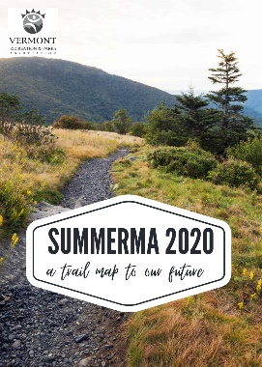
Summerama Camp Staff Training

The in-person Summerama Camp Staff Training was also cancelled in 2020 because of the pandemic. The committee did still deliver a virtual session along with a new Resource Guide to help communities plan for a summer like no other during a pandemic. The committee was able to make some great new connections with staff at the Department of Health, Breen Holmes, along with staff from Vermont AfterSchool. We look forward to carrying these relationships forward and working together more in the future.

STATE TRACK MEET

The annual state track meet was another event that had to be cancelled in 2020 because of gathering restrictions from the pandemic. Several national virtual options we offered, but we look forward to seeing all the athletes again in person in 2022!

ANNUAL CONFERENCE

The 77th Annual Vermont Conference on Recreation was held virtually on September 23 & 24, 2020 via live Zoom links.
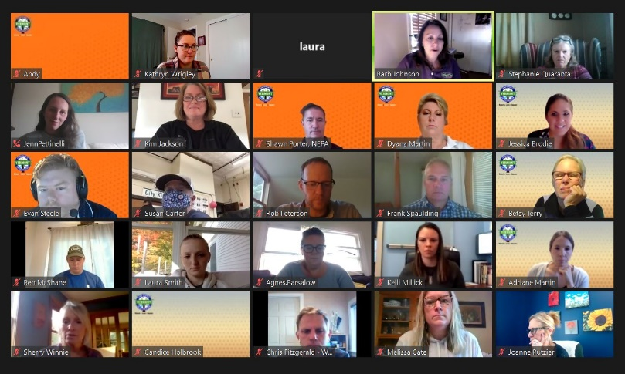
Though the conference was completely different in 2020 and we were not able to gather in person, there were many things that helped bring us together. The conference committee worked for months via virtual meetings to still plan a schedule that was entertaining, educational, and allowed time for conversation even in a virtual session.
This year’s conference attracted 28 talented speakers from all over the country, including 4 members of the prestigious American Academy of Park & Recreation Administration – Michael Kirschman (VA), Lisa Paradis (MA), Jamie Sabbach (CO), & Cindi Wight (VT). Attendees tuned in from all over Vermont, including many small communities and rural towns that otherwise may not have been able to attend in person. In total, we had over 100 attendees to our virtual conference!
Perhaps the highlight of the conference was keynote speaker Michael Kirschman, CPRP, Director, Virginia Beach Parks & Recreation. Michael spoke about Addressing pressing issues such as social inequity, health and obesity, crime and safety, and protecting our natural resources. He highlighted how our daily actions save lives. How Parks & Recreation work decreases health care costs and improves individuals’ health & creates a safer community.
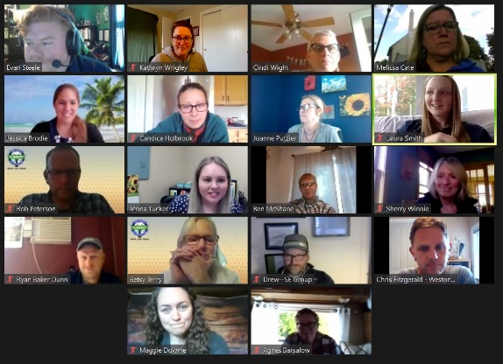
Though the exhibit hall could not be held in person, we were able to offer several “Coffee Talk” sessions that allowed Exhibitors each 3 minutes to share about their company and show a video. We had 17 exhibitors join us for our first ever virtual conference experience. We are so grateful for the continued support of all of our commercial members and conference exhibitors!
The Theresa S. Brungardt awards were not awarded this year, but Wendy Flickenger delivered some great words during the beginning of the Keynote session in absence of the awards.
Finally, the Vermont’s Finest Silent Auction once again raised over $4,000 in proceeds from over $10,000 in auction donations in it’s first ever virtual bidding format. The fine work of conference committee member and auction organizer Joanne Putzier of Burlington Parks, Recreation & Waterfront was a smashing success.

Performance Showcase:
The Annual Performance Showcase was another event that had to be cancelled in 2020 because of the Pandemic. With every struggle though comes new opportunities, and we are looking forward to working with the VT Arts Council and many other local artists to help bring back this great event in 2022.

Covid-19 Effects on the VRPA

The pandemic had many effects on the association this past year. We applied and received two rounds of Payroll Protection Funds to offset lost revenues from cancelled programs. We built new relationships with state officials and leaders, as well as other associations and professionals. We started offering weekly/monthly Director’s calls to help provide a forum for Parks & Recreation professionals to connect virtually and navigate new and difficult situations. It was a hard year, but with the challenges and changes came some great opportunities that we will continue to carry forward.
 | VRPA EDUCATION PROGRAM PARTICIPANTS
 |  | 2020-21 | 2019-20 | 2018-19 | 2017-18 | 2016-17 | 2015-16
Annual Meeting |  | 31 | 15 | 45 | 39 | 44 | 45
Certified Pool Operator Course |  | 17 | 22 | 27 | 31 | 26 | 17
CPSI Playground Inspector Course |  | 30 | 42 | - | - | 46 | -
Quarterly Meeting – December |  | 33 | 34 | 34 | 28 | 33 | 35
Quarterly Meeting – March |  | 183 | 31 | 31 | 29 | 28 | 31
State Conference - Delegates |  | 97 | 125 | 125 | 104 | 115 | 104
State Conference - Vendors |  | 17 | 34 | 34 | 42 | 43 | 40
Summerama |  | 75 | 160 | 217 | 91 | 117 | 144
VT/NH Maintenance Workshop |  | / | 79 | / | - | - | -
CPRPs & CPREs |  | 40/4 | 40/1 | 40/1

VRPA MEMBERSHIP
2020-21 | 2019-20 | 2018-19 | 2017-18 | 2016-17
392 members | 309 members | 302 members | 344 members | 372 members
MEMBERSHIP - Membership in the association continues to grow, with new members joining throughout the year. We saw several new members this year from around the State, as our Association helped provide information and resources during the on-going pandemic. Nearly every Vermont community with part-time or full-time paid recreation staff is a VRPA member.

EDUCATION - Participation in our education program offerings met or exceeded expectations this year. We were able to get a VRPA Zoom account and more webinar CEU sessions than we ever have in the past. Webinars including an Esports webinar, Fitness experience webinar, as well as other training courses such the PMT course, and special guests as part of Quarterly meetings . Over the past several years, VRPA has made a concerted effort to encourage members to become certified park and recreation professionals, or CPRPs. The number of Vermont CPRPs has doubled in the last 5 years. We haven’t tracked this number before but it has been added here so that we will, into the future. We hope to have more CPREs (Executives) by next year.

VRPA PROGRAM PARTICIPATION
 | 2020-21 | 2019-20 | 2018-19 | 2017-18 | 2016-17
State Track Meet | / | 300 | 312 | 290 | 433
Showcase Audience | / | 45 | 52 | 37 | 54
Summer Tickets Sold | / | 3,488 | 3,569 | 3,714 | 4,826
PROGRAMS - Due to the ongoing Pandemic, many of the programs that the VRPA traditionally offered had to be cancelled in 2020. This is one major factor that lead to the association seeking PPP (Payroll Protection funds), as many of these programs help offset VRPA expenses each year. With gathering restrictions and travel guidelines, we were not able to host the annual state track meet, the annual performance showcase, or sell discount tickets. Blue Cross Blue Shield of Vermont had sent their annual sponsorship dollars to us for the annual track meet prior to the pandemic, so those funds will be carried over and used in 2021.

PUBLICATIONS - VRPA continues to offer all our publications and event notices in electronic format, including three newsletters each year, conference and meeting/event brochures, and weekly recreation check-ins. The weekly recreation check-in continues to be one of our most highly rated member benefits, which we enhanced this year by using Constant Contact!

FINANCES - For many years, revenue from the VRPA discount ticket program was enough to solely support the association budget. In 2001, we sold more than 15,000 tickets and ten years later, our sales were down to 10,782 tickets. In recent years, we have sold fewer than 5,000 tickets each summer, still a significant revenue source but significantly less than what we used to enjoy. As ticket sales started to decline, the Executive Committee strategically began planning for a more diverse revenue stream. You can see in the revenue charts below that the portion of the total revenue from tickets has continued to decline and the revenue generated by the conference, membership, and education and programs has steadily increased. This has been accomplished by increasing registration and membership fees, along with growth in training offerings and increased participation in membership, trainings, and programs. Thanks to the PPP funds we were able to receive this year, we ended the year with a balanced budget, and a net that will carry forward into 2021 to help offset additional expenses.
We ended FY 2020-21 year with:
- $97,535.00 in total revenue
- $87,185.54 in total expenses
- $10,349.46 net balance
- $6,700 in Silent Auction income
- $104,030.68 in total assets

VRPA REVENUE HISTORY - % of Total
 |  | 2020-21 | 2019-20 | 2018-19 | 2017-18
Tickets |  | 0% | 56.2% | 56.2% | 58.0%
Conference |  | 5.3% | 19.0% | 19.0% | 17.1%
Membership |  | 6.5% | 6.8% | 6.8% | 5.9%
Programs |  | 0% | 6.1% | 6.1% | 6.6%
Education |  | 3% | 12%* | 9.4% | 12.2%*
Other |  | 85.2% | 2.5% | 2.5% | 0.2%
 | * CPSI course offered
In 2015, the Executive Committee approved up to $10,000 from the reserve fund to increase the Executive Director compensation to more accurately reflect the amount of work being performed as the association has grown. That first year, we used $3,088 to balance the budget. Every year since, we have included part of this reserve fund appropriation to balance the proposed budgets but each year, revenues have exceeded expectations and we have not needed to draw from the reserve fund. The Executive Committee did approve a transfer up to $3,500 in FY2019-20 to balance the year end budget because of the effects COVID-19 has had on the Association.
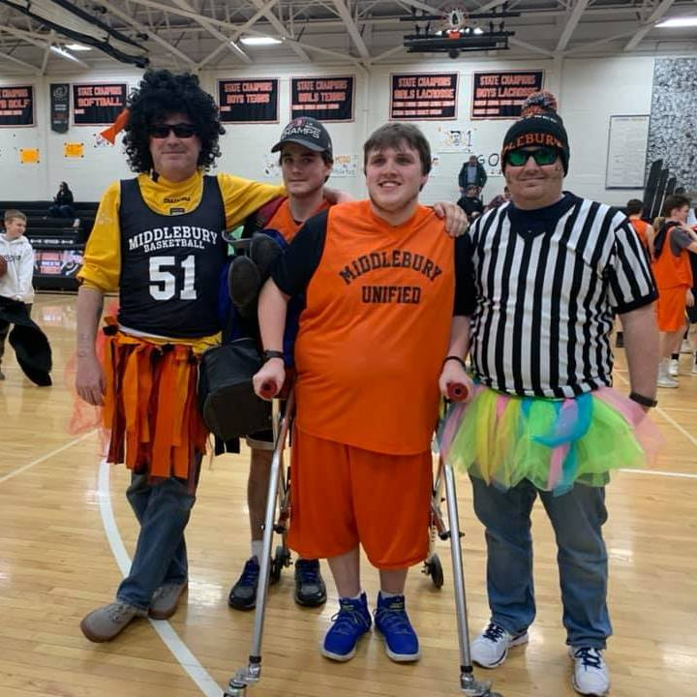
At the close of FY2020-21, membership is strong and participation in programs and trainings is high. Thank you to all our members for choosing to be part of VRPA…collectively we continue to do great things. Time after time, we go into committee meetings without pre-conceived outcomes, we dialogue rigorously, and the results are amazing. This is your organization and you will get far more value from your affiliation if you choose to engage. We have opportunities for everyone.

Thank you VRPA President, Ally Vile, and the entire Executive Committee for guiding us through this past year. To everyone who has served on a committee this past year, thank you! Our association has grown to be so well-regarded because of all your efforts.

So many of you have been truly inspiring this past year adapting and changing your departments to serve your communities through a global pandemic. This may have been one of the hardest years ever, but we have all learned some amazing new things and will only grow because of these experiences. The work you are all doing is essential and inspirational. It has been amazing serving as your Executive Director this year. I am inspired by our members and astonished at all we have accomplished. It is a thrill to see so many new faces at our meetings. Though this coming year may be different than we have all ever seen before, we can and will get through this together. Keep up the good work, and I hope to SEE you all again soon!

2020-21 VRPA Executive Board
President-Ally Vile President Elect-Rob Peterson Treasurer-Melissa Cate Secretary-April Cioffi Past-Pres.-Scott Hausler
Members-at-Large: Matt Frazee Brett Leonard Reuben Allen Drew Pollak-Bruce
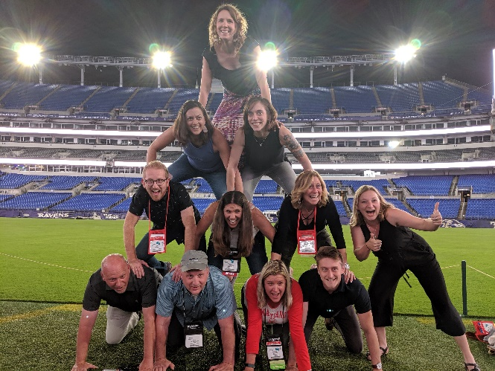
Executive Director: Jessica Brodie

